|  |
| --- |
| **LAP** |
| PAPER, PLASTIC & BOTTLE DISPOSING FACILITY WITH CARBON |
| FOOTPRINT |

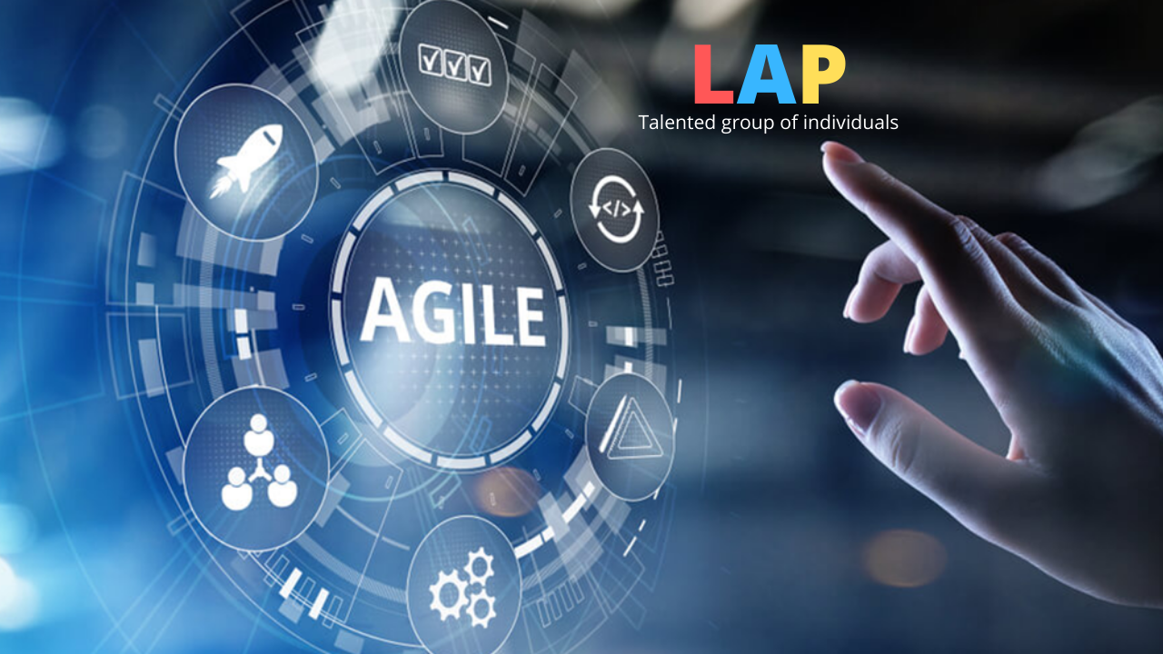

|  |  |  |  |
| --- | --- | --- | --- |
| **Roll No.** | **Name** | **SAP ID** | **BATCH** |
| **24** | **lalit mohan singh bohra** | **500066192** | **Batch-1** |
| **8** | **anirudh singh rawat** | **500071254** | **Batch-1** |
| **35** | **pranav bajaj** | **500071250** | **Batch-1** |
| **41** | **rakshit bhatt** | **500070379** | **Batch-1** |

Contents

Problem Statement 1

Introduction 2

Review 3

Software Methodologies 4

Implementation 5

Waterfall 6

Agile 7

Rational Unified Process (RUP) 8

Spiral Model 9

Software Characteristic 11

Functionality 11

Usability 11

Reliability 12

Efficiency 13

Portability 14

Maintainability 15

Lean Development 16

Rapid Application Development 17

Entity Relation Diagram (ER) 19

Data Flow Diagram 20

Level 0 20

Level 1 20

Process Flow Diagram 21

Description of coin out 22

Program Evaluation Review Technique Chart (Pert Chart) 23

# Problem Statement

*“India generates nearly 26,000 tonnes of plastic waste every day, making it the 15th biggest plastic polluter globally.”*(Source)

**How to stop someone from throwing garbage on the streets/roads?**

This is the question that comes to our mind when we think about how harmful it is to throw plastic on roads/streets.

Some consequences of throwing garbage on the streets:

* It is fatal for the stray animals, mainly cows and dogs that end up mistaking plastic for food.
* Some of the materials may also be poisonous or contain sharp objects therefore damaging the animal’s vital organs or severely injuring them.
* Cleaning up waste requires a huge amount of money that is financed by taxpayers that could be used in more productive ways.

As we all know in India, people won't do anything if they are not getting something in return.

In response to this problem, our project proposes giving people something for just throwing plastic/paper in the machine other than throwing them on the roads.

# Introduction

Our team has come up with an intuitive idea for disposing of garbage that specifically includes paper, plastic and glass bottles. Everyone disposing of garbage will be provided with money as an incentive with an additional alleviation of reducing their carbon footprint.

The project is undertaken with an aim to develop a machine that can identify the waste material disposed into it into three materials/categories

* Plastic
* Paper
* Glass Bottles

The waste will be appropriately placed in separate containers for each material and the weight of paper and glass bottles can be calculated electronically and subsequently compensated with the appropriate amount of money.

# Review

As to make our project (Paper /Plastic Bottle Disposing Facility with Carbon Footprints) best from others we have made it budget friendly and its processing is already been shown in the introduction. With budget friendly its been made with the best quality of material. It also includes Carbon Footprints which shows how much efforts has been put by the people to recycle the waste in their country. This product has been made with low risk i.e., low risk in product quality as well as in budget.

With the help of our machine, people will get encourage towards recycling waste materials as it will decrease their carbon footprints and they will get money accordingly. This machine also follows iterative waterfall model as it replace many different process which was done by people to single machine.

# Software Methodologies

Scrum Frameworks of Agile Model

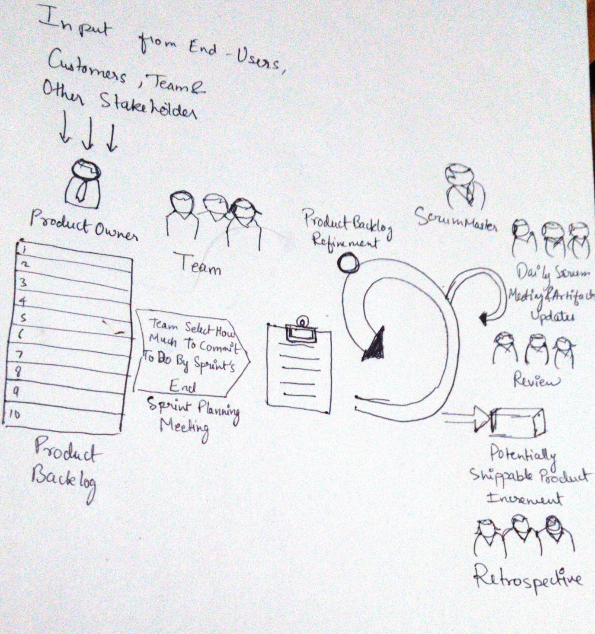

Firstly we take input from the Customer, Team and Stakeholder on requirement of the product.

We have a requirement of waste material which can harm the environment .After we have create a product backlog development team have create a sprint backlog on which we have to deliver weekly or monthly. We will deliver prototype of our disposing facility on carbon footprint. Development team with the investor will have discussion over the product weekly on what have they done on the product and if investor have something to add to product if any new idea .For example: If investor or customer want to add liquid paper ourdevelopment team always be ready to change and adapt new things.As the product goes on documentation is done simultaneously with the working prototype.New sprint backlog will being on what we we have done previous session. What we have create till now.

## Implementation

To simply the way of approaching the project the project is divided into following phases

* Interfacing of Barcode sensor
* Interfacing the actuators
* Coin dispensing mechanism

Interfacing the barcode sensor: This is the most important phase of the project as the working of entire project depends on interfacing the barcode sensor and getting the values of barcode. Every bottle in which can be accepted as waste by the machine has a unique barcode printed on it. When the bottle is places in machine the barcode sensor reads the value of barcode and sends the string to microcontroller, which process the data and takes the decision regarding the accepting or rejecting the bottle.

Interfacing the actuators : The actuators such as DC motors and servo motors are requires for bottle accepting mechanisms and coin dispensing mechanisms of the project. After reading the value from the barcode, if the bottle is acceptable, the microcontroller sends the signal to the actuator to open the gate which accepts the bottle and also to the servo motor to actuate to dispense the coin.

The coins dispensing mechanism: This is driven by a high precision servo motor and is use to dispense the coins in return of bottle. This consists of a mechanical system which is used to dispense the coins. 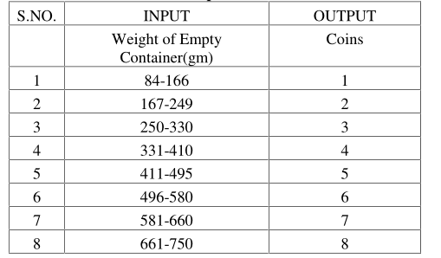

Carbon footprint coins

## Waterfall

In waterfall model any given project /activities is been divided into different linear sequential phases in which each phase depends on the previous one according to the task. In this model it is divided into linear flow with specified sequence. It also helps users to understand that with each further level is progressed it is because of the completion of the previous level. (which means progress only flows in one direction i.e., if one level has been progressed it cannot go to the back level).

Advantages

1. Easy to understand
2. Simple to handle
3. Saves time
4. Easy to test and analyze

Disadvantages

1. Matches precise needs
2. Cannot be used for maintenance projects
3. No option to find out the possible outcome
4. Not good for long /ongoing projects

## Agile

Agile Software Development Methodology is a kind of method which comprises many different approaches. It is mainly use to work together to achieve common goal i.e., the person/people designing the software sits with the users/customer so that they should be able to know what customers want from them or they can visualize what the customers want from them as the final product. Due to this it minimize the risk of the users not satisfied with their final product. It is a good thing that it helps to create the software in short time boxes (also known as iterations), which can be last from one week to one month.

Advantages

1. Adaptive approach that responds to changes favorably
2. Allows direct communication
3. Improved quality by finding and fixing defects quickly

Disadvantages

1. Lacks documentation efficiency
2. Chances of getting off-track as outcomes are not clear

## Rational Unified Process (RUP)

Rational Unified Process is a very popular software development methodology. RUP works in an iterative way, which means that it performs different iterations. And at each iteration, it performs four phases.

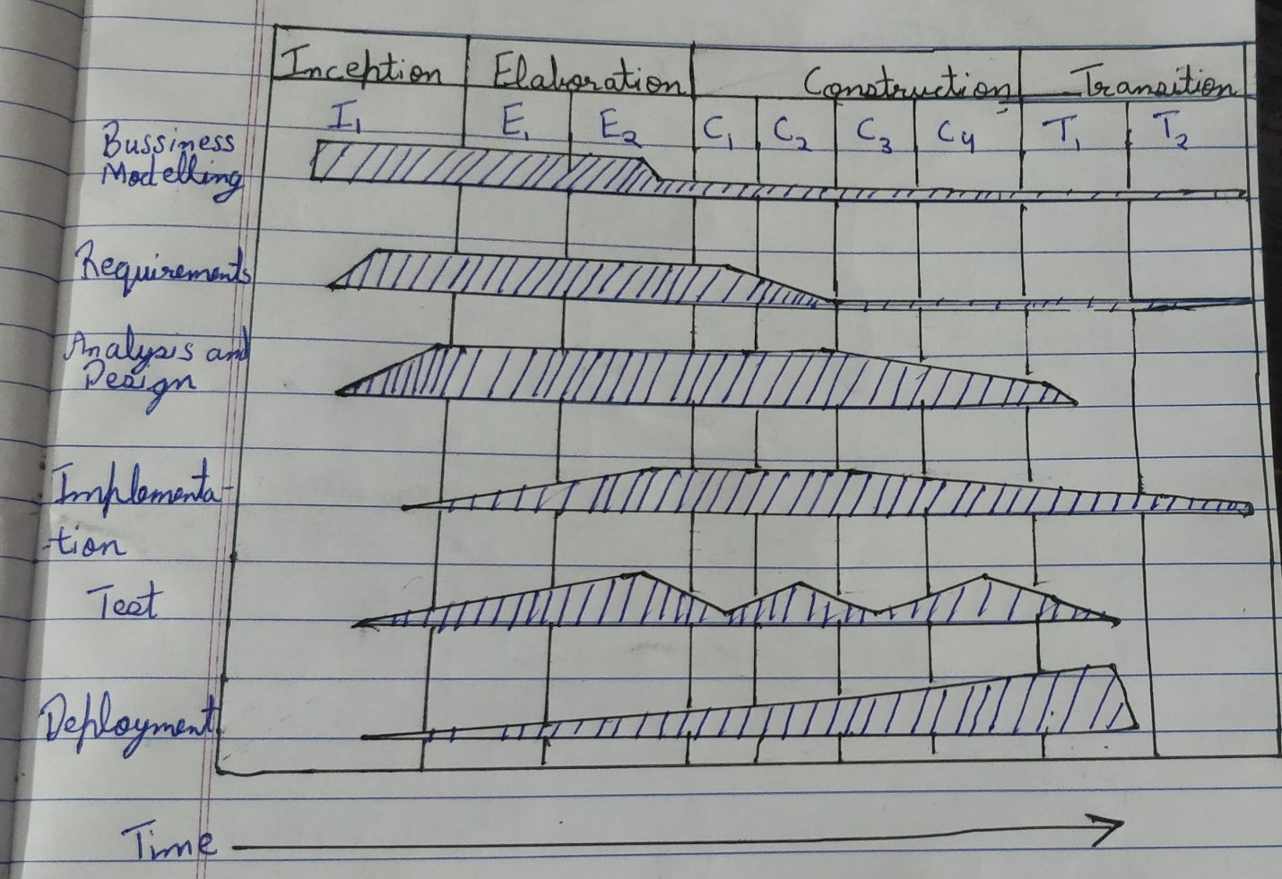

RUP hump chart

* **Inception**: In this phase the work is mostly to sculpt the system. So basically figuring out what is the scope of the project. So that we can be able to perform initial cost and budget estimates.
* **Elaboration**:In this phase we focus on domain analysis and define the basic architecture for the system.
* **Construction**: It is where the bulk of the development actually occurs and is where most of the implementation happens.
* **Transition**: In this phase system goes from development into production so that it becomes available to users.This is the phase in which other activities in the software development become less relevant and deployment becomes the main one.

*Using Inception phase we can find the estimate budget of our project and using elaboration we can define the architecture of our project.*

## Spiral Model

Spiral Model is a combination of waterfall model and iterative model. Each phase in Spiral model begin with design goal and ends with client reviewing. Software is developed in a series of incremental releases.

**Q: When to use Spiral model ?**

A: When project is large.

When risk and project evaluation is important.

When requirements are unclear and complex.

When changes may require at any point of time.

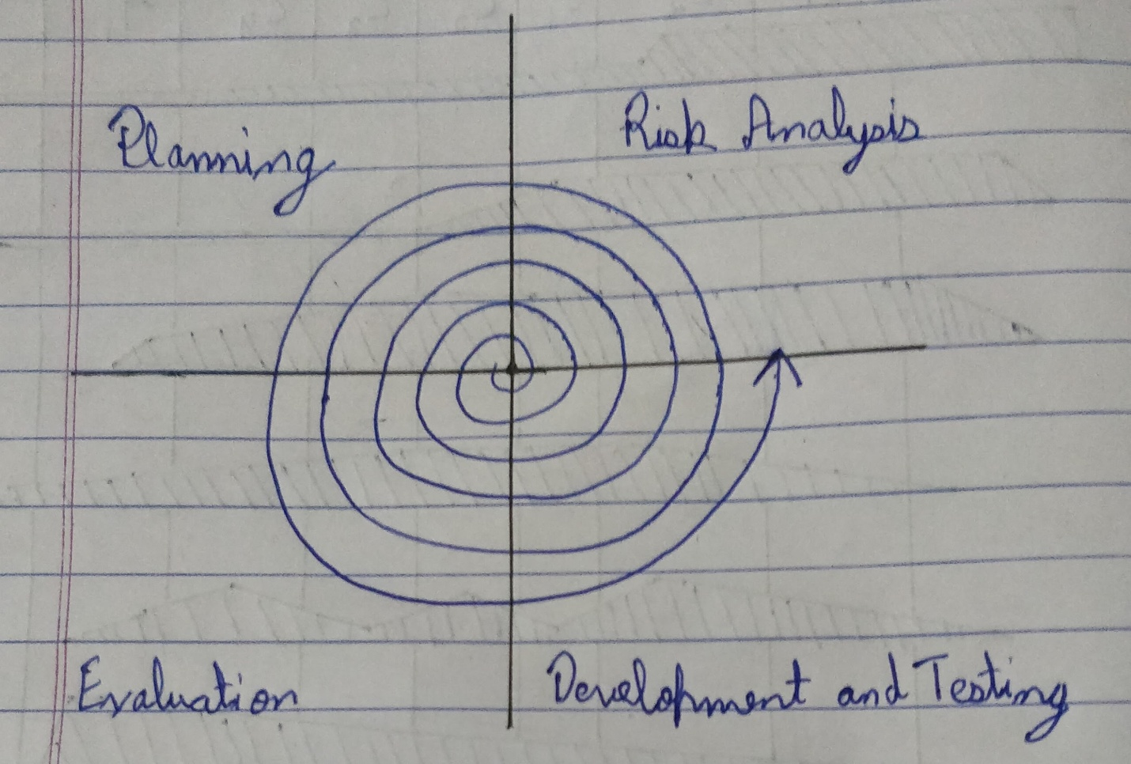

A spiral model

*We can use this in our project as cost estimation becomes easy, development is fast and features can be added in a systematic way.*

# Software Characteristic

## Functionality

it refers to degree of performance of the software against it intended purpose it basically means are the required functions

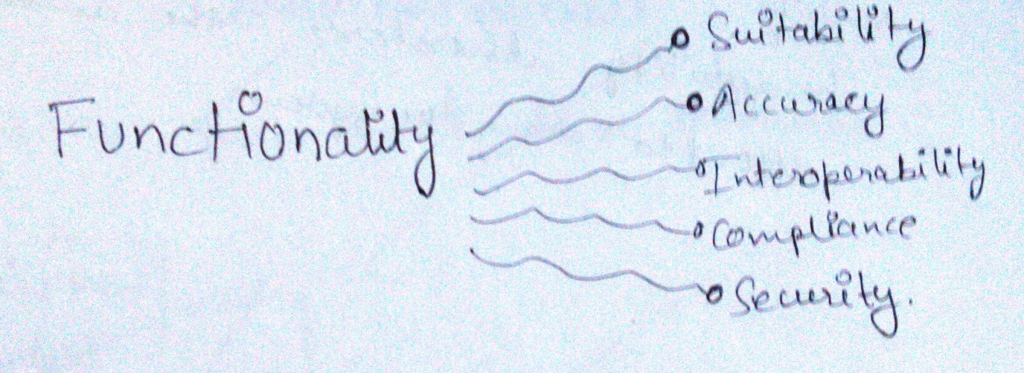

## Usability

Usability refers to the extend to which the software can be used with ease.OR the amount of time required to learn how to use the software should be less.

Usability

covers

Understandability

Learnability

Operability

*We can use this in our project in a way that it takes less amount of time for the user to understand to machine.*

## Reliability

A set of attributes that bear on the capability of software to maintain its level of performance under stated conditions for a stated period of time.

Reliability

covers

Recoverability

Fault Tolerance

Maturity

*We can use this in our project to predict the number of faults in the software of our machine before the commercial release.*

## Efficiency

Any software which uses the resources available in the most efficient manner and most effective command manner, which is easy to use. Software use to make effective storage space and the timing as per requirement. It also save time.

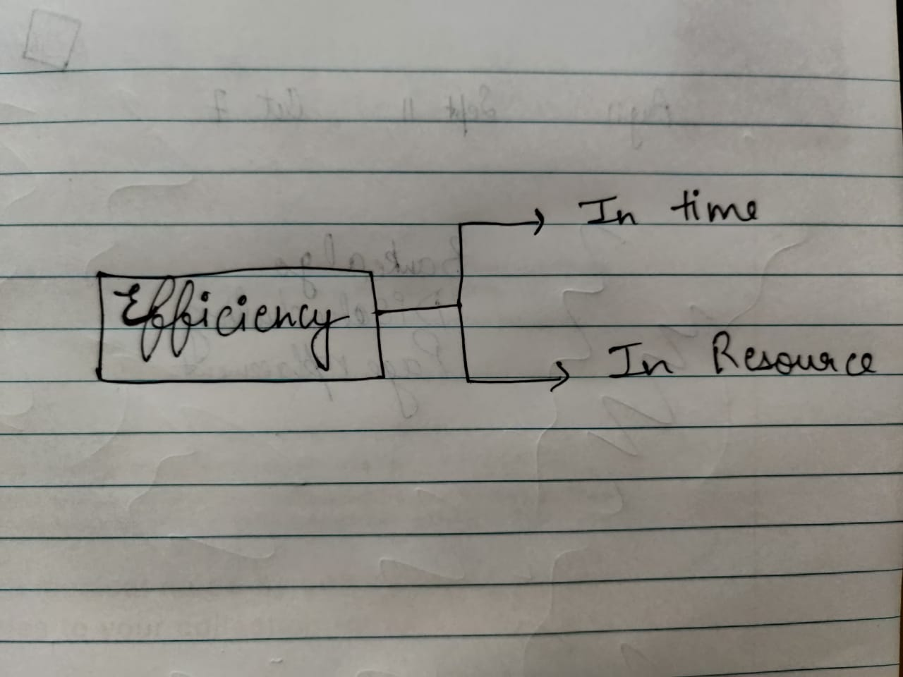

## Portability

Mainly Portability refers to the ability of the software which can be transferred from one environment to another without any changes or minimum changes. It simple language , the ability of software to properly function in different kind of softwares and hardwares.

In addition to that , Robustness and integrity are also important characteristics.

Robustness – It refers the degree in which the software keeps functioning

Integrity – It refers to which degree unauthorized access to the software.

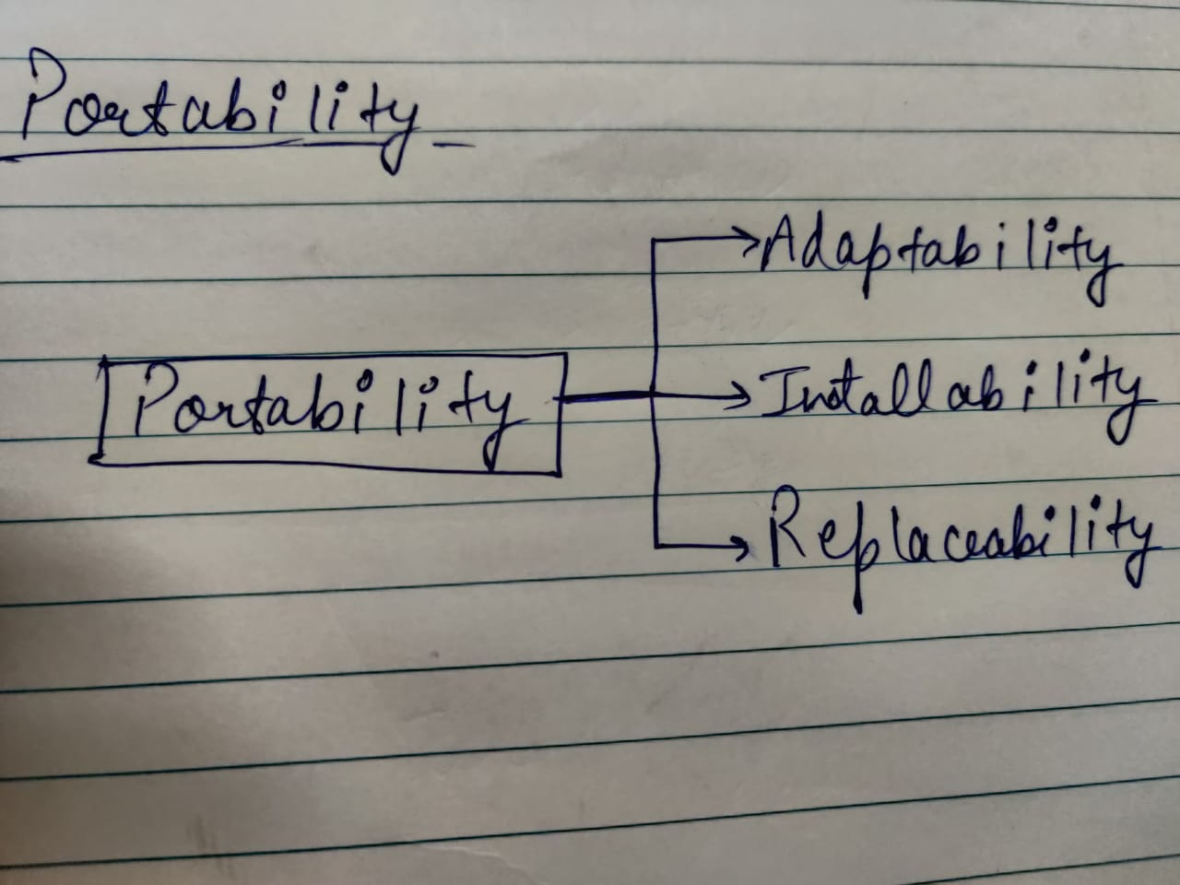

## Maintainability

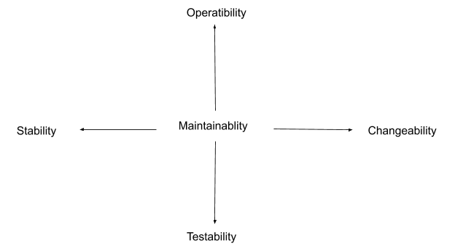

* Analysability: It is the ability to identify the root cause of a failure within the software.
* Changeability: It is the difficulty that would be pertained in implementing a change to the system.
* Stability: It is the sensitivity of a system to a change. For example, a system can be negatively affected by a change/update.
* Testability: It is the difficulty or effort attained when  testing after system changes.

## Lean Development

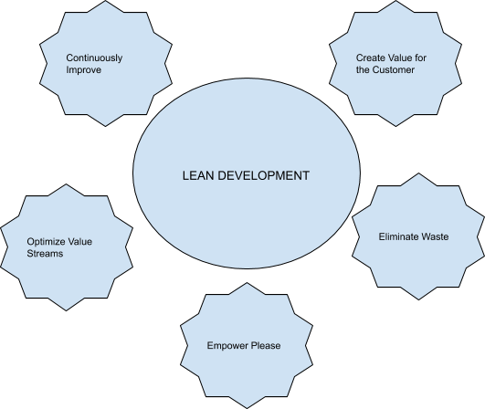

Lean Development a product development paradigm with an end-to-end focus on creating value for the customer, eliminating waste, optimizing value streams, empowering people, and continuously improving.

## Rapid Application Development

The rapid application development model emphasizes on delivering projects in small pieces. If the project is large, it is divided into a series of smaller projects. Each of these smaller projects is planned and delivered individually.

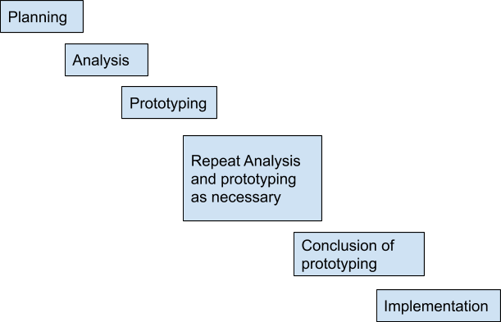

The phases of RAD model are listed below.

* Planning: In this phase, the tasks and activities are planned. The derivables produced from this phase are project definition, project management procedures, and a work plan. Project definition determines and describes the project to be developed. Project management procedure describes processes for managing issues, scope, risk, communication, quality, and so on. Work plan describes the activities required for completing the project.
* Analysis: The requirements are gathered at a high level instead of at the precise set of detailed requirements level. Incase the user changes the requirements, RAD allows changing these requirements over a period of time. This phase determines plans for testing, training and implementation processes. Generally, the RAD projects are small in size, due to which high-level strategy documents are avoided.
* Prototyping: The requirements defined in the analysis phase are used to develop a prototype of the application. A final system is then developed with the help of the prototype. For this, it is essential to make decisions regarding technology and the tools required to develop the final system.
* Repeat analysis and prototyping as necessary: When the prototype is developed, it is sent to the user for evaluating its functioning. After the modified requirements are available, the prototype is updated according to the new set of requirements and is again sent to the user for analysis.
* Conclusion of prototyping: As a prototype is an iterative process, the project manager and user agree on a fixed number of processes. Ideally, three iterations are considered. After the third iteration, additional tasks for developing the software are performed and then tested. Last of all, the tested software is implemented.
* Implementation: The developed software, which is fully functioning, is deployed at the user's end.

# Entity Relation Diagram (ER)

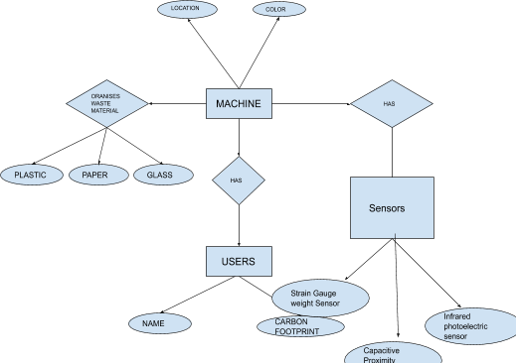

# Data Flow Diagram

## Level 0

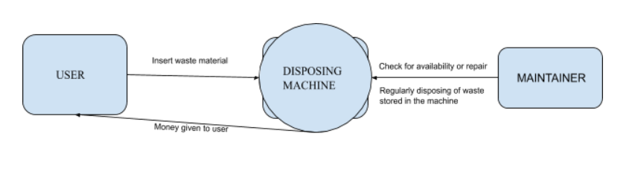

## Level 1

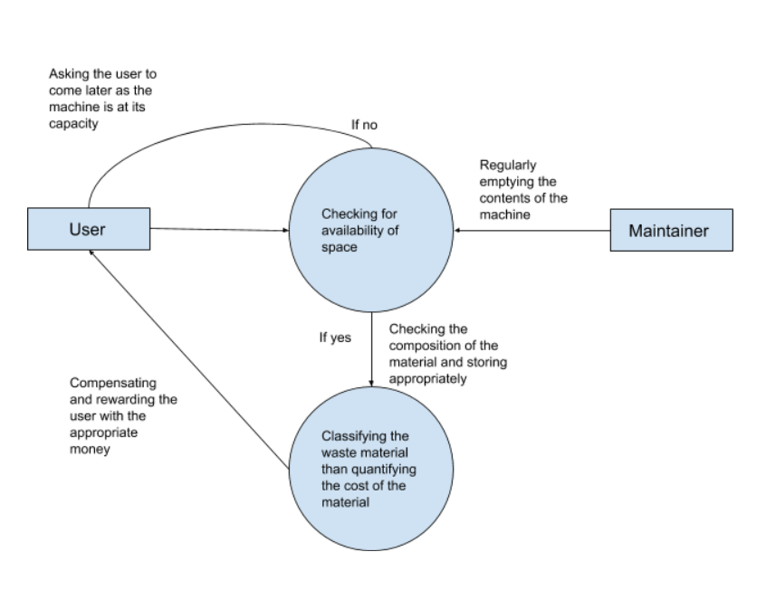

# Process Flow Diagram

Start

Coin out according to weight

Coin out according to weight

Paper, plastic and bottle detection

Stop

Receive Item

Item Received

No

Yes

No

Yes

Detect the presence of water

Yes

No

Weight of item >=411

**Following table contains**

No **further details.**

Yes

## Description of coin out



# Program Evaluation Review Technique Chart (Pert Chart)

